**Teck Saksham**

**Case Study Report**

**Data Analytics with Power BI**

“Supply Chain Analysis of Inventories”

“Government Arts & Science College”

|  |  |
| --- | --- |
| NM ID | Name |
| 2FEBAF6DB2431A8A9124578B40489DBF | R.Sivanathiya |

Trainer Name : R.Umamaheshwari

Master Name : R.Umamaheshwari

ABSTRACT

This study conducts a comprehensive analysis of inventories within supply chains, aiming to enhance understanding and optimize management practices. Inventories serve as crucial assets in supply chains, impacting operational efficiency, financial performance, and customer satisfaction. Through a structured review of literature, this paper examines various dimensions of inventory management, including demand forecasting, procurement strategies, inventory optimization techniques, and risk mitigation approaches. Moreover, it explores the integration of emerging technologies such as blockchain, IoT, and Al in inventory management to improve visibility, accuracy, and responsiveness. Additionally, this study investigates the influence of external factors such as globalization, market dynamics, and disruptions on inventory dynamics within supply chains. By synthesizing existing knowledge and identifying gaps, this research provides valuable insights for practitioners and scholars to develop effective inventory management strategies, enhance supply chain resilience, and achieve competitive advantages in dynamic business environments.

**INDEX**

|  |  |  |
| --- | --- | --- |
| Sr.No | Table of content | Page no |
| 1 | Chapter 1: Introduction | 4 |
| 2 | Chapter 2: Services and Tools required | 6 |
| 3 | Chapter 3: | 7 |
| 4 | Chapter 4: Modeling and Result | 9 |
| 5 | Conclusion | 18 |
| 6 | Future Scope | 19 |
| 7 | Reference | 20 |
| 8 | Links | 21 |

**CHAPTER 1**

**INTRODUCTION**

**1.1 Poblem Statement**

Supply chain analysis of inventories using Power BI involves leveraging the platform's capabilities to gain insights into inventory levels, movements, costs, and performance across the supply chain. This analysis helps organizations optimize inventory management, reduce costs, and improve efficiency. Define key performance metrics for inventory analysis, such as inventory turnover, carrying cost, stockout rate, and fill rate. Calculate these metrics in Power BI using DAX formulas. Gain visibility into your supply chain by analyzing inventory movements, lead times, and supplier performance. Use Power BI to track inventory flows and identify bottlenecks or inefficiencies in the supply chain. By using Power BI for supply chain analysis of inventories, organizations can gain valuable insights into their inventory management practices and make data-driven decisions to improve efficiency and reduce costs across the supply chain.

**1.2 Proposed Solution**

A proposed statement for a supply chain analysis of inventories could be: "Our supply chain analysis of inventories aims to assess the efficiency and effectiveness of inventory management practices across all stages of the supply chain, identifying opportunities for optimization, cost reduction, and improved customer satisfaction."

**1.3 Feautures**

* **Quick Insights:** Power BI's Quick Insights feature automatically generates insights and trends from your inventory data, helping you discover hidden patterns and opportunities for improvement.
* **Integration with Other Tools:** Power BI integrates seamlessly with other Microsoft products, such as Excel, SharePoint, and Teams, as well as with third-party tools and services.

This allows you to leverage existing data and workflows for inventory analysis.

* **Visualizations:** Power BI offers a variety of visualization options, including bar charts, line charts, scatter plots, maps, and more. These visualizations help you explore and analyze your inventory data from different perspectives and gain valuable insight

**1.4 Advantages**

* **Cost Reduction:** By optimizing inventory levels across the supply chain, companies can minimize carrying costs, reduce stockouts, and lower overall inventory expenses.
* **Improved Efficiency:** Analyzing inventory flows helps identify inefficiencies in the supply chain, allowing for streamlined processes and better resource allocation.
* **Enhanced Customer Service:** Maintaining optimal inventory levels ensures that products are readily available to meet customer demand, leading to improved satisfaction and retention.
* **Risk Mitigation:** By monitoring inventory levels and supply chain performance, businesses can identify and mitigate risks such as disruptions in supply, supplier reliability issues, and market fluctuations.

**1.5 Scope**

The scope of supply chain analysis of inventories encompasses various aspects such as inventory optimization, demand forecasting, inventory carrying costs, lead time analysis, supplier performance, inventory turnover, risk management, and technology integration. It involves evaluating the entire supply chain from procurement to distribution to ensure efficiency, cost-effectiveness, and responsiveness to market demand. Additionally, it may involve assessing the impact of external factors like market trends, regulations, and disruptions on inventory management strategies.

**CHAPTER 2**

**SERVICES AND TOOLS REQUIRED**

**2.1 Services Used**

* **ourcing:** Assessing where raw materials or components are obtained. This involves evaluating suppliers for quality, reliability, and cost-effectiveness.
* **Manufacturing:** Understanding the production process for tools or the delivery process for services. This includes analyzing efficiency, capacity utilization, and potential bottlenecks.
* **Distribution:** Examining how inventories are transported from manufacturing facilities to distribution centers and ultimately to end-users or service locations. This involves logistics optimization and transportation management.
* **Inventory Management:** Analyzing inventory levels at different stages of the supply chain to ensure optimal stock levels while minimizing excess inventory and associated costs.

**2.2 Tools And Software Used**

**Tools**

* **Power BI :** The main tools for this project is Power BI, which will be used to create interactive dashboards for real time visualization.
* **Power Query:**Use Power Query to transform and clean your data, ensuring that it's in the right format for analysis

**Software Requiments:**

* **Power BI Dekstop:**This is a windows application that you use to create report and publish them to Power BI.
* **Power BI Mobile:**This is a mobile application that you can use to access your reports and dashboards on the go.

**CHAPTER 3**

**ARCHITECTURE**

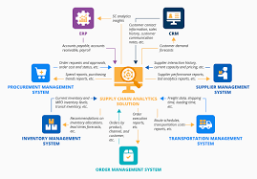

**1.Data Collection:** Gathering data on inventory levels, demand forecasts, supplier performance, lead times, transportation costs, and other relevant metrics.

**2. Inventory Management Systems:** Utilizing inventory management systems (IMS) to track inventory levels, reorder points, and lead times. This could involve using technologies like RFID, barcoding, or lot sensors for real-time tracking.

**3. Demand Forecasting:** Employing statistical models and forecasting techniques to predict future demand for products, allowing for more accurate inventory planning.

**4.Supplier Relationship Management (SRM):** Evaluating supplier performance, negotiating contracts, and managing relationships to ensure timely delivery of materials and components.

**5. Inventory Optimization:** Analyzing inventory levels across the supply chain to minimize holding costs while ensuring sufficient stock to meet customer demand. Techniques like ABC analysis, EOQ (Economic Order Quantity), and safety stock calculations are used.

**6. Transportation and Logistics:** Assessing transportation modes, routes, and carriers to optimize the movement of goods while minimizing costs and transit times.

**CHAPTER 4**

**MODELING AND RESULT**

**Data Modeling:**

Power BI's data modeling capabilities enable you to create relationships between different data tables, define calculated columns and measures using DAX (Data Analysis Expressions), and create hierarchies. This is essential for structuring your inventory data for analysis.DAX is a powerful formula language in Power BI that allows you to create calculated columns, measures, and calculated tables. This enables you to perform complex calculations and analysis on your inventory data.

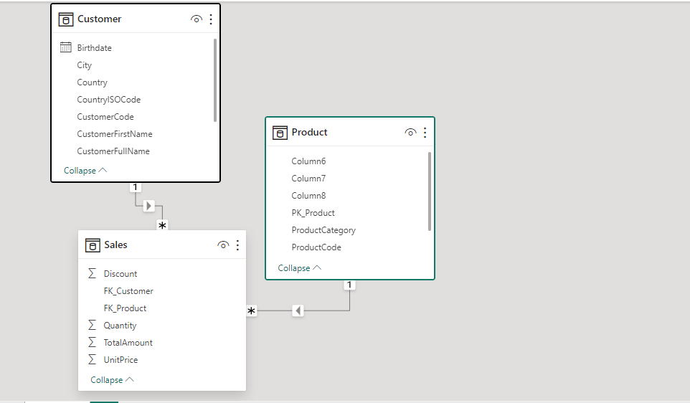

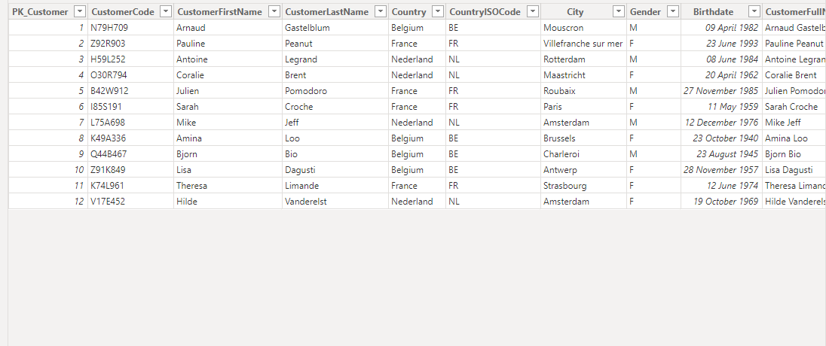

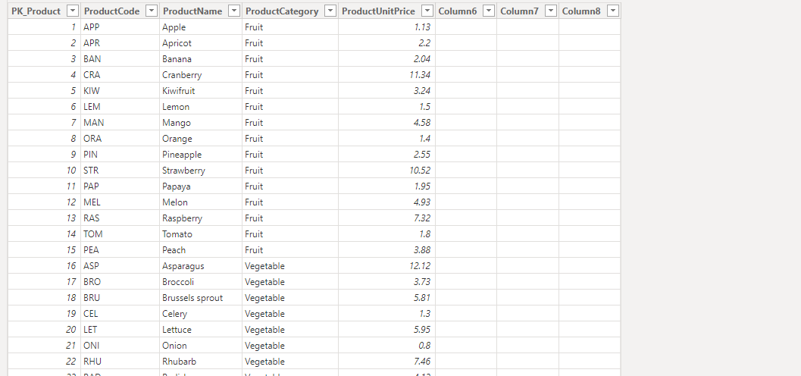

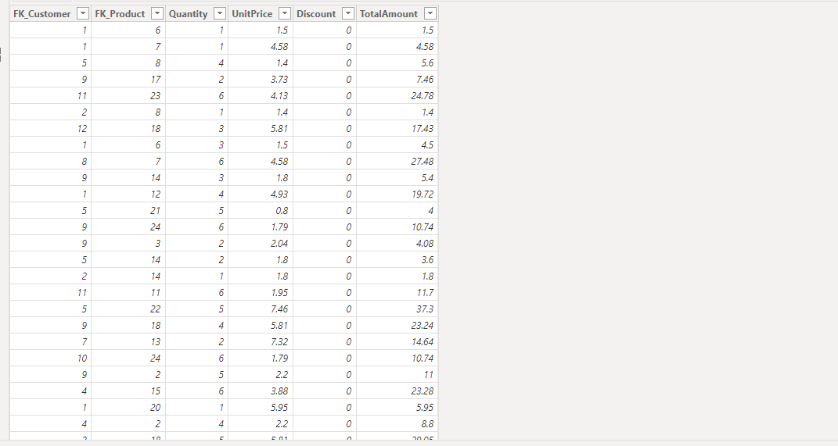

**Dashboard**

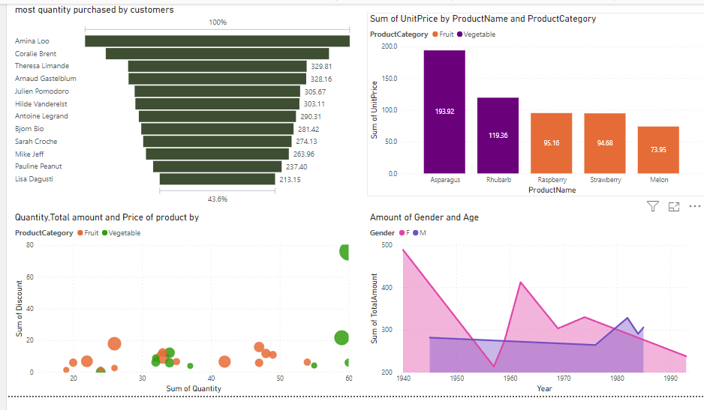

**RESULT:**

1. Optimized Inventory Levels:* By analyzing inventory data, you can optimize inventory levels to ensure that you have enough stock to meet customer demand without holding excess inventory. This can help reduce carrying costs and improve cash flow.

2. Improved Demand Forecasting:* Power BI can help improve demand forecasting by analyzing historical sales data and identifying trends and patterns. This can help you better predict future demand and adjust inventory levels accordingly.

**CONCLUSION**

**1. Identification of inefficiencies:** The analysis may reveal areas within the supply chain where inefficiencies exist, such as excess inventory levels, stockouts, or bottlenecks in distribution.

**2. Opportunities for optimization:** By understanding inventory patterns and flows, the analysis can uncover opportunities to optimize inventory management processes, such as implementing just-in-time inventory practices or improving forecasting accuracy.

**3. Cost-saving measures:** Recommendations may be made to reduce carrying costs associated with excess inventory or to streamline procurement processes to lower costs.

**4. Risk mitigation strategies:** The analysis may identify vulnerabilities within the supply chain, such as reliance on single suppliers or geographic concentrations of inventory, and propose strategies to mitigate these risks.

**5. Performance metrics:** Establishing key performance indicators (KPIs) and benchmarks for inventory management can help track progress over time and ensure ongoing improvements in supply chain efficiency.

Overall, the conclusion of a supply chain analysis of inventories should provide actionable insights and recommendations for enhancing the efficiency, effectiveness, and resilience of the supply chain.

**FUTURE SCOPE**

Futurescope supply chain analysis of inventories involves assessing various aspects such as demand forecasting, inventory optimization, supplier performance, transportation efficiency, and risk management. It aims to streamline operations, reduce costs, improve customer satisfaction, and mitigate supply chain disruptions. Advanced technologies like Al, IoT, and blockchain are often utilized to enhance visibility, agility, and responsiveness across the supply chain.

**REFERENCE**

<https://www.selecthub.com/supply-chain-management/supply-chain-analysis/>

<https://www.gartner.com/en/supply-chain/insights/supply-chain-analytics>

**LINKS**